Valuation Model User Instructions

Before you start:

The **blue** numbers/cells require your attention. They either require you to input something or just check that you agree with how it is done.

The **black** numbers are calculated; you do not need to change them.

The **red** sheets are client-facing sheets.

The colors used in the model are:

* Gray fill color: HEX#F6F6F6, RGB Sliders Red 246, Green 246, Blue, 246
* Orange fill color: HEX#F8CBAD, RGB Sliders Red 248, Green 203, Blue, 173

Steps to perform the valuation:

1. Duplicate the Model
   1. Copy and rename the model with the company's name and valuation date.
2. Input Assumptions
   1. Follow instructions on the sheet.
   2. Choose "Yes" from the drop-down if using an Asset Schedule. Switch to "No" to exclude it from calculations.
3. Enter Cap Table
   1. **Important**: This model can only handle simple Cap Tables. It will not be able to handle:
      1. Participating Securities
      2. Cumulative dividends
      3. Warrants
      4. Option pools
      5. More than five seniority levels
      6. More than 36 breakpoints
   2. You must enter the option from lowest to highest price.
   3. Start by entering “Security Type” and follow the instructions on the sheet.
4. Input Financials
   1. Adjust projections for Income Statement and Balance Sheet as needed.
   2. You don’t need to input anything in the “Cash Flow” sheet.
5. Public Comps
   1. Go to FactSet. Find a competitor and go to “Comps Analysis.”
   2. Under “Comps Table,” add competitors.
   3. Use the custom template called “Comps Table.”
      1. If you don’t have a custom template, make one that matches the columns in the “FactSet Public Comps” sheet like this:
   4. Download the comps to an Excel file.
   5. Copy all the rows with companies and paste them into the “FactSet Public Comps” sheet.
   6. Look at your competitors in the “Public Comps” sheet and exclude outlier multiples by putting a “0” in the box with “1”.
   7. Use the buttons to choose between median, average, 25th percentile, and 75th percentile.
   8. Choose weighting for the different types of multiples.
6. Transaction Comps
   1. Find the SIC or NAICS code that relates best to your business.
   2. Go to DealStats and enter your SIC/NAICS code.
   3. Choose the dates that you want deals from—for example, the last five years.
   4. 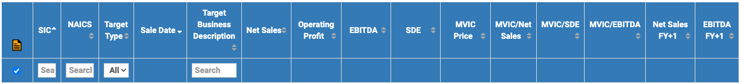Go to “display” and add “Net Sales FY+1” and “EBITDA FY+1”. These must show up last in the table. Your table header should look like this:
   5. Download “only displayed fields” to an Excel file.
   6. Look through the companies and delete any rows with companies you don’t want in your comps set.
   7. Copy all the rows with companies and paste them into the “DealStats Transaction Comps” sheet.
   8. In the “Transaction Comps” sheet, you can now choose weighting and use the buttons to select between Median, Average, 25th percentile, and 75th percentile.
7. Run the Backsolve
   1. Save your changes.
   2. Decide the implied volatility.
   3. Run the Breakpoints and Backsolve by using shortcut: “command + shift + b” or “control + b”
8. Formatting Macro
   1. Use the Formatting Macro to format the Public Comps, Transaction Comps, Breakpoints, and Backsolve sheets.
   2. By using shortcut: “command + shift + n” or “control + n”
9. WACC
   1. Determine your Beta and Equity Risk Premium
10. DCF
    1. Decide on Long-Term Growth Rate
    2. Press buttons to choose valuation approach: GGM, Revenue, H-Model, or EBITDA.
11. GGM Sensitivity Model
    1. The sensitivity Model works only for the GGM valuation approach and should only be a part of the valuation when GGM is used. The sheet is automatically hidden if you use another approach.
    2. Determine the increments you want for the sensitivity model.
12. Summary Page
    1. Choose the weighting of your valuation method.
    2. Ensure total percentage equals 100%.
    3. Hide the methods you don’t want to show.
13. Export to PDF
    1. Adjust the print area for a good preview.
    2. Highlight the **red** Sheets.
    3. Export Valuation to PDF.